SECTION A
- Which of the following polymer is stored in the liver of animals? (i) Amylose (ii) Cellulose (iii) Amylopectin (iv) Glycogen
- Which of the following statements is not true about glucose?
(i) It is an aldohexose.
(ii) On heating with HI it forms n-hexane.
(iii) It is present in furanose form.
(iv) It does not give 2,4-DNP test.
- Three cyclic structures of monosaccharides are given below which of these are anomers.
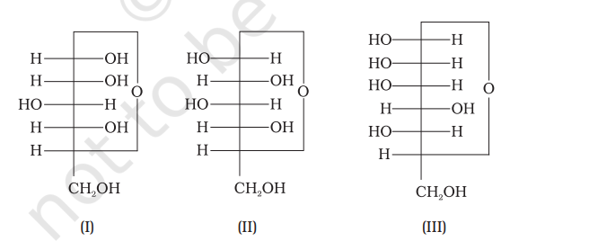
(i) I and II
(ii) II and III
(iii) I and III
(iv) III is anomer of I and II
- Which of the following reactions of glucose can be explained only by its cyclic structure? (i) Glucose forms pentaacetate.
(ii) Glucose reacts with hydroxylamine to form an oxime.
(iii) Pentaacetate of glucose does not react with hydroxylamine.
(iv) Glucose is oxidised by nitric acid to gluconic acid.
- Assertion: D (+) – Glucose is dextrorotatory in nature.
Reason: ‘D’ represents its dextrorotatory nature.
ECTION B [2 marks]
- Under what conditions glucose is converted to gluconic and saccharic acid?
- How do you explain the presence of five -OH groups in glucose molecules?.
- How do you explain the presence of an aldehydic group in a glucose molecule?
- What is essentially the difference between a-form of glucose and B-form of glucose?
SECTION C [3 marks]
- How do you explain the presence of an aldehydic group in a glucose molecule?
- Write down the structures and names of the products formed when D-glucose is treated with (i) Hydroxylamine (ii) Acetic anhydride (iii) hydrogen cyanide
- A wide variety of reagents and conditions, such as heat, organic compounds, pH changes, and heavy metal ions can cause protein denaturation. Anyone who has fried an egg has observed denaturation. The clear egg white turns opaque as the albumin denatures and coagulates. No one has yet reversed that process. However, given the proper circumstances and enough time, a protein that has unfolded under sufficiently gentle conditions can refold and may again exhibit biological activity After reading the above passage, answer the following questions:
(i) Define the term ‘denaturation of protein.
(ii) Which of the following structures remains intact during denaturation? (a) Primary structure (b) Secondary structure (c) Tertiary structure (d) Quaternary structure
- Write two examples of denaturation of proteins.
- Differentiate fibrous proteins and globular proteins

